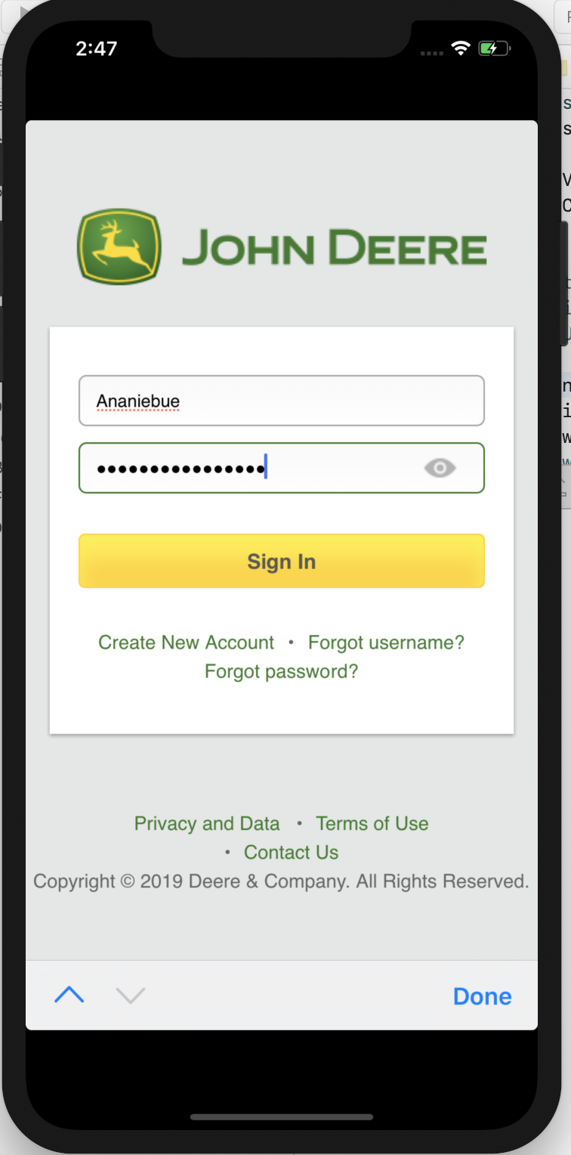

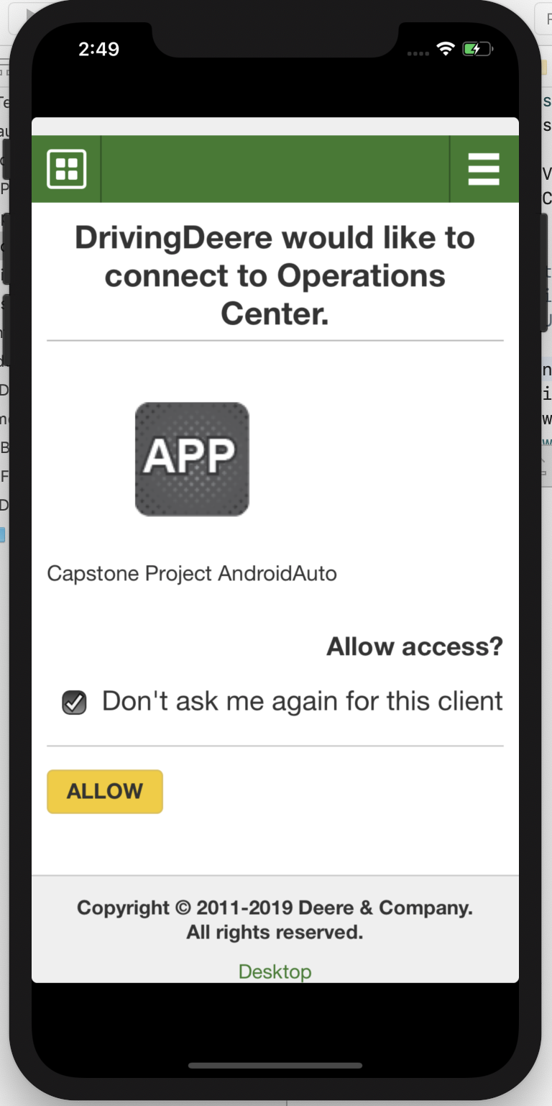

**2019-12-02 14:47:22.097033+0100 JDAPITest[73567:1139220] [ProcessSwapping] 0x101a962c0 - ProvisionalPageProxy::ProvisionalPageProxy: pageID = 6 navigationID = 6 suspendedPage: 0x0**

**2019-12-02 14:47:24.257359+0100 JDAPITest[73567:1139220] [ProcessSwapping] 0x101a96420 - ProvisionalPageProxy::ProvisionalPageProxy: pageID = 6 navigationID = 7 suspendedPage: 0x0**

**2019-12-02 14:47:36.315803+0100 JDAPITest[73567:1139220] INFO: -[JDLoginViewController loginPageFinishedLoading] line 167 $ Login page loaded**

**2019-12-02 14:47:53.072808+0100 JDAPITest[73567:1139220] INFO: -[JDRequestManager performGETRequestForURL:configuration:success:failure:] line 109 $ GET request at URL: https://partnerapi.deere.com/platform/users/@currentUser with ETag: (null)**

**2019-12-02 14:47:53.181105+0100 JDAPITest[73567:1139841] CredStore - performQuery - Error copying matching creds. Error=-25300, query={**

**class = inet;**

**"m_Limit" = "m_LimitAll";**

**ptcl = htps;**

**"r_Attributes" = 1;**

**sdmn = "/platform/users/@currentUser";**

**srvr = "partnerapi.deere.com";**

**sync = syna;**

**}**

**2019-12-02 14:47:53.297431+0100 JDAPITest[73567:1139220] WARN: -[JDRequestManager performGETRequestForURL:configuration:success:failure:]_block_invoke line 245 $ Cannot fetch data from url: [https://partnerapi.deere.com/platform/users/@currentUser] with error: [Error Domain=com.alamofire.error.serialization.response Code=-1011 "Request failed: unauthorized (401)" UserInfo={NSLocalizedDescription=Request failed: unauthorized (401), statusCode=401, NSErrorFailingURLKey=https://partnerapi.deere.com/platform/users/@currentUser, com.alamofire.serialization.response.error.data={length = 0, bytes = 0x}, com.alamofire.serialization.response.error.response=<NSHTTPURLResponse: 0x600001a772c0> { URL: https://partnerapi.deere.com/platform/users/@currentUser } { Status Code: 401, Headers {**

**"Content-Length" = (**

**60**

**);**

**"Content-Type" = (**

**"application/json"**

**);**

**Date = (**

**"Mon, 02 Dec 2019 13:47:53 GMT"**

**);**

**"Www-Authenticate" = (**

**"Basic realm=\"/platform/users/@currentUser\""**

**);**

**} }}]**